**Neptune3Pro&Plus&Max**

**-Firmware Update Instructions**

* **File Description:**

**Board firmware**

**Screen firmware**

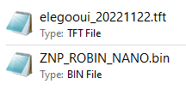

* **Preparation Steps:**

1. Format the TF card as shown in the picture.

Requirement: File system (F): FAT32

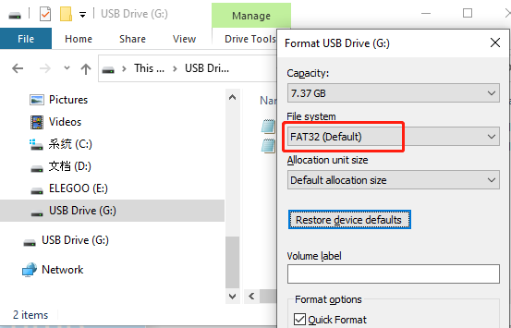

1. As shown in the picture, copy the above two firmware files to the root directory of the TF card.

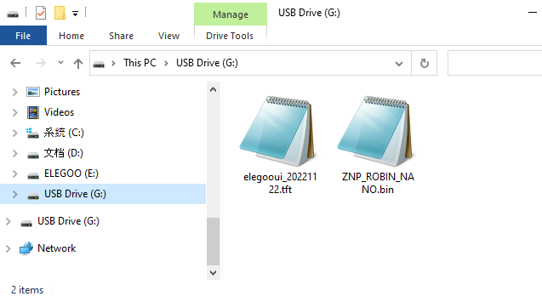

* **Screen Firmware Update:**

1. Loosen the screws, remove the back cover of the screen; pay attention to the card insertion direction, and insert the TF card.

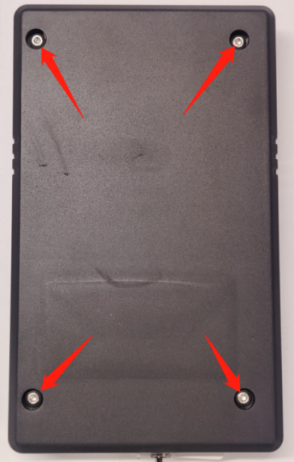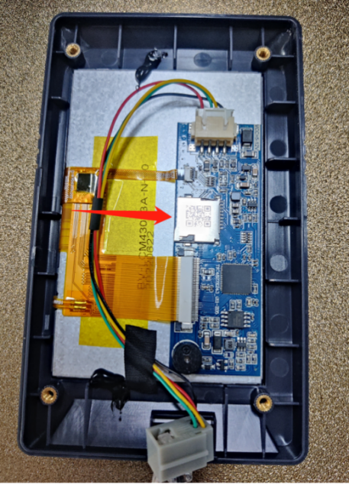

1. Restart the power supply and wait for the firmware to be loaded. The firmware loading process and the completed interface display are shown in the picture. After the loading is complete, remove the TF card and restart the printer. (Time required for the screen firmware update: about 60 seconds.)

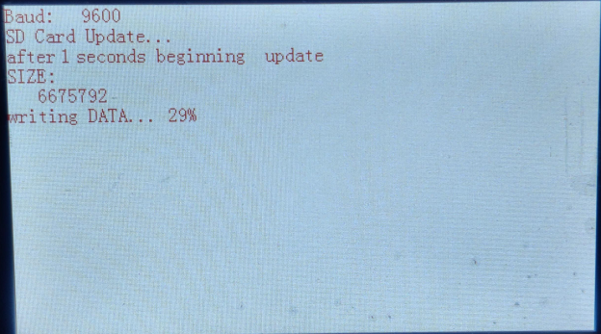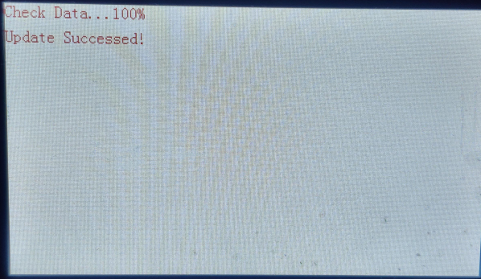

* **Board Firmware Update:**

Insert the TF card into the printer, then restart the power supply, and wait for the firmware loading to complete; the screen display of the firmware loading process is as shown in the picture, and it will directly enter the main interface after the firmware update is completed. (Board firmware update time: about 15 seconds.If you can't enter the main interface for a long time, format the TF card to reload the firmware.)

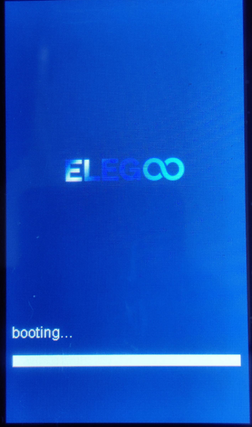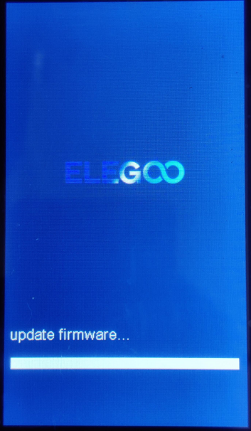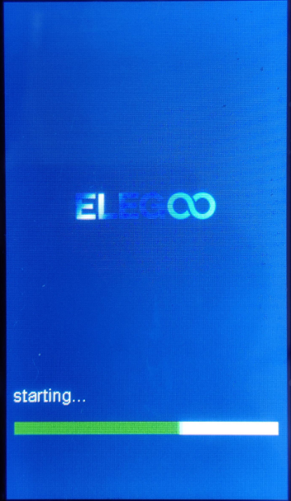

**Notice:**

1. The screen firmware will not be renamed after loading, and can be loaded repeatedly, so the TF card must be removed after updating the screen firmware; after the board firmware is successfully loaded, it will be renamed to "ZNP_ROBIN_NANO.CUR". You can rename the suffix and load it again.



1. If you disconnect the power supply or remove the TF card before the screen firmware completes loading, you will not be able to enter the main operation interface normally after restarting the power supply, as shown below:

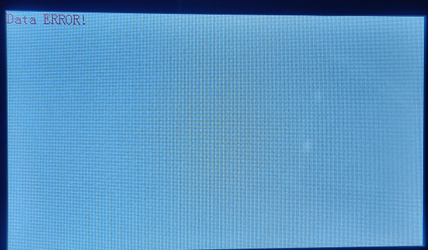

1. You can check the UI version and board firmware version in 【Settings】 → 【About Machine】.

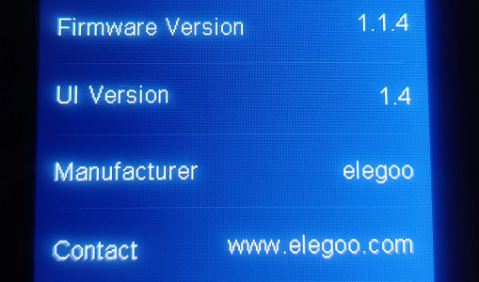

1. After reloading the firmware, the leveling value will be cleared to zero and re-leveling is required.
2. Screen power-down recovery will lead to some information loss (such as firmware version number), which is a normal situation and will not affect the printing. Simply restart the machine and the lost info can be displayed.